4.Draw a UML diagram for ATM System using CASE tool. The banking system allows
a customer to access the financial transactions by ATM System, it has a step-by-step
process describe the work of this process and elaborate the what are the work can do by
customer, banking system, administrator and technicians with the ATM system.

AIM:

To design a UML diagram for an ATM system that illustrates the interactions and processes between the customer, banking system, administrator, and technicians, using a CASE tool.

PROCEDURE:

Identify Actors:
- Customer: Accesses the ATM to perform transactions.
- Banking System: Manages account and transaction processes.
- Administrator: Configures and maintains the ATM system.
- Technician: Repairs and maintains the hardware and software of the ATM.
Define Use Cases:
- Customer: Withdraw cash, deposit funds, check balance, transfer funds, change PIN.
- Banking System: Validate transactions, update account balances, generate logs.
- Administrator: Monitor ATM logs, update software, configure settings.
- Technician: Diagnose and repair faults, maintain ATM hardware.
Create Diagrams:
- Use Case Diagram: Shows interactions between actors and system functionalities.
- Class Diagram: Depicts system structure and components.
- Sequence Diagram: Represents step-by-step transaction processes.

DIAGRAM:
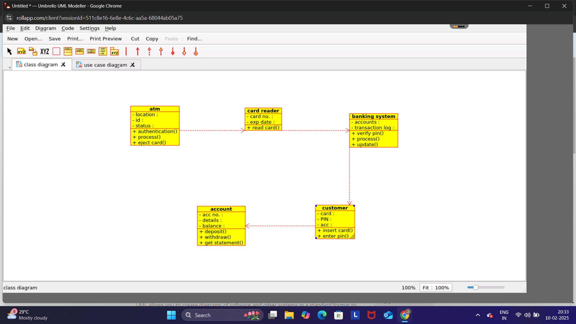

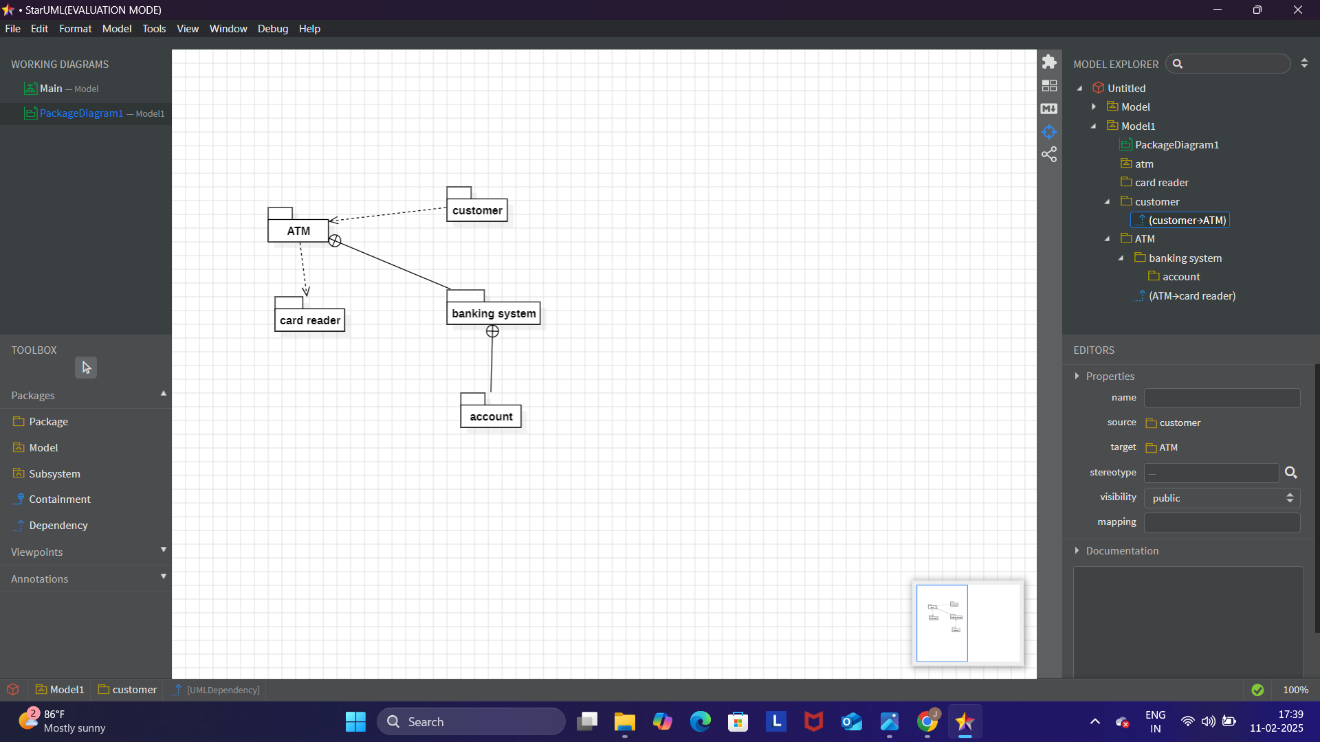

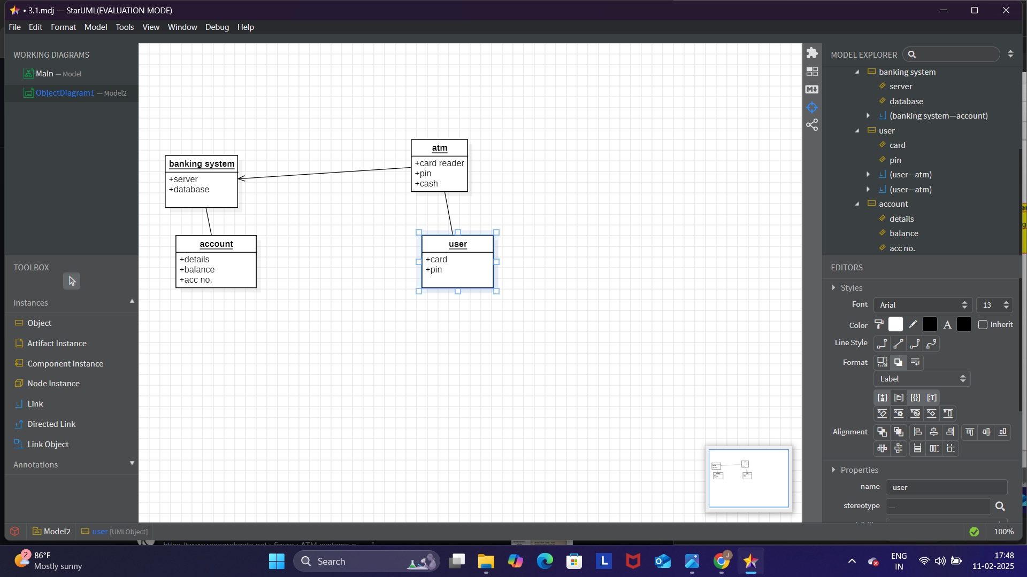
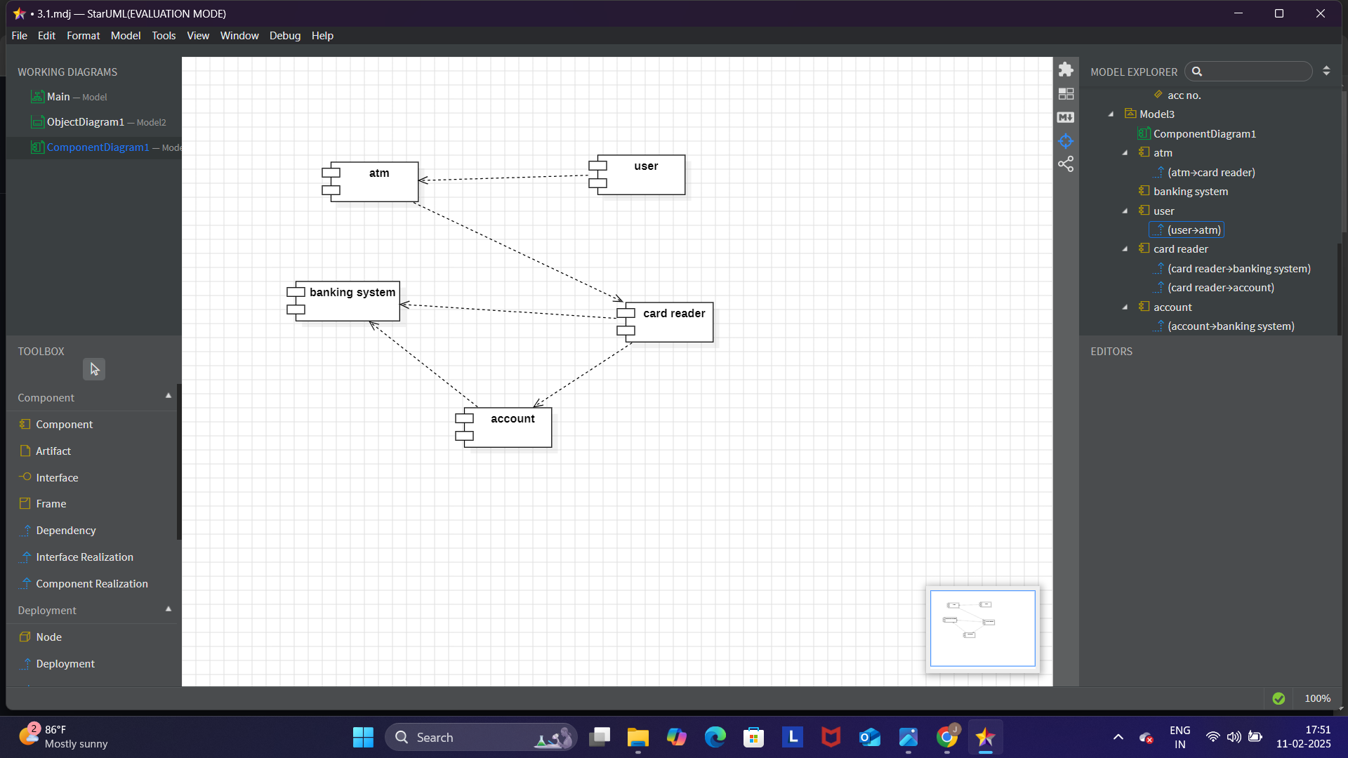

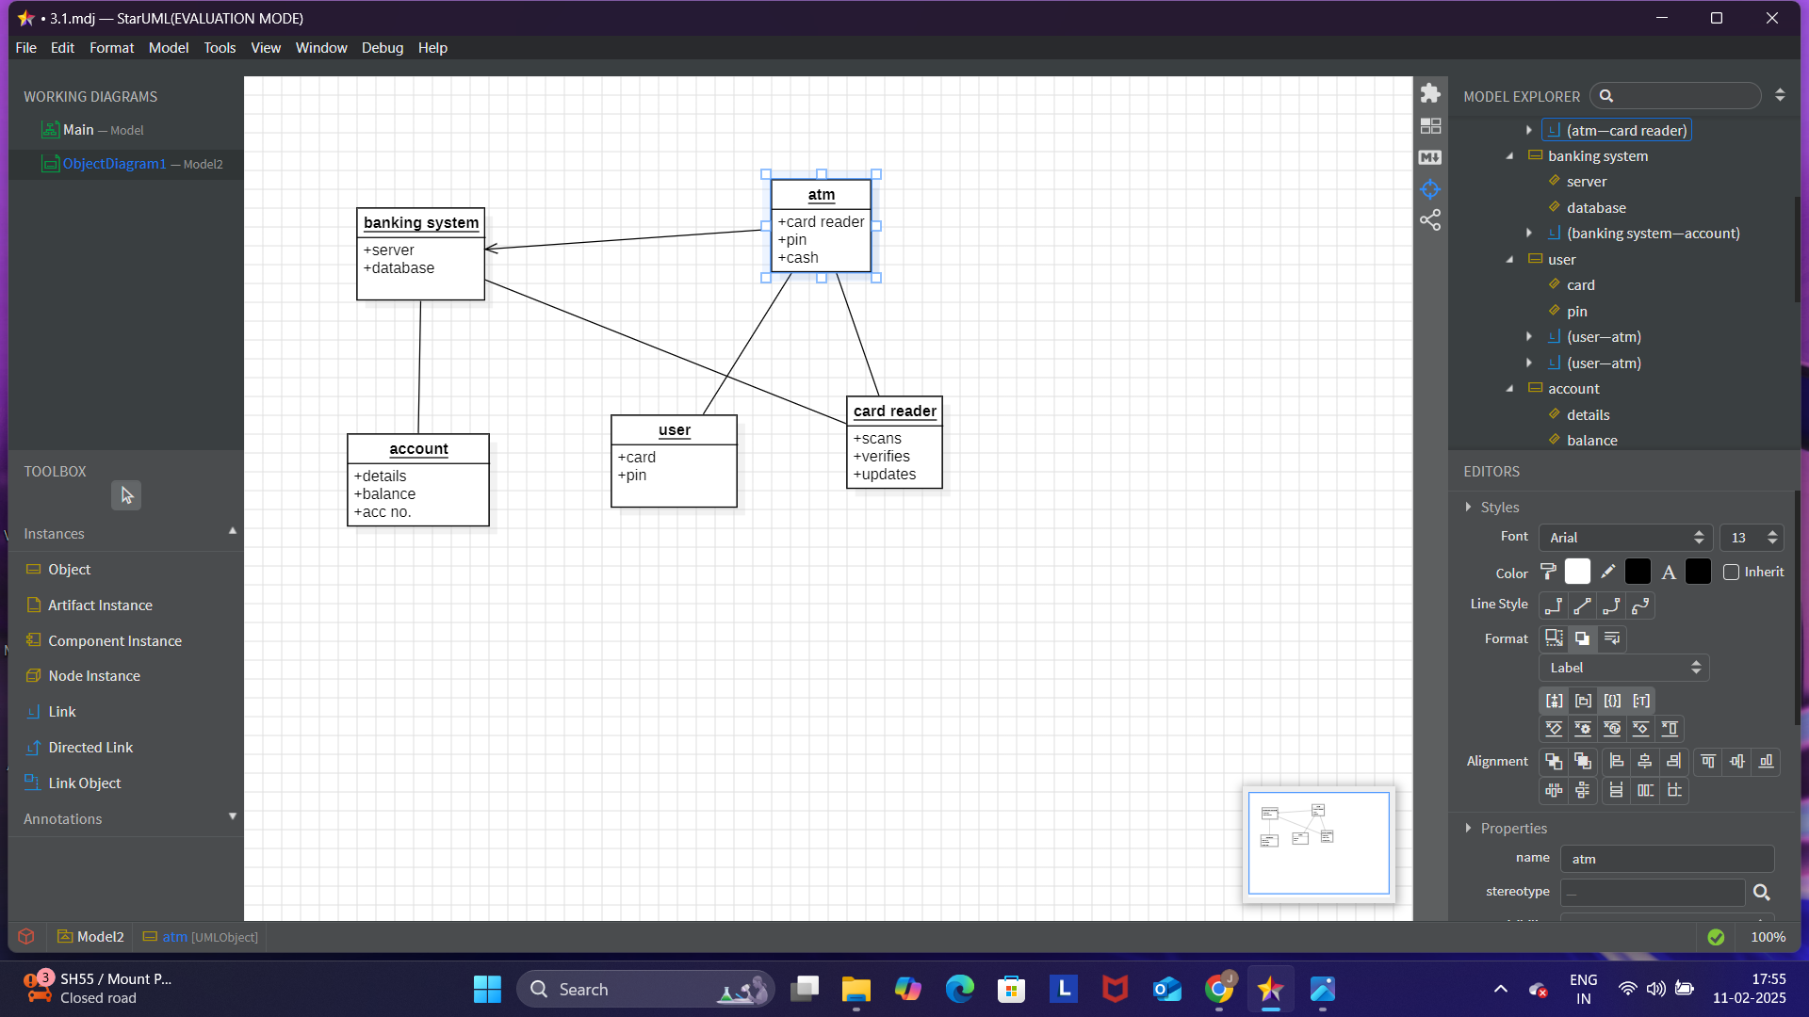
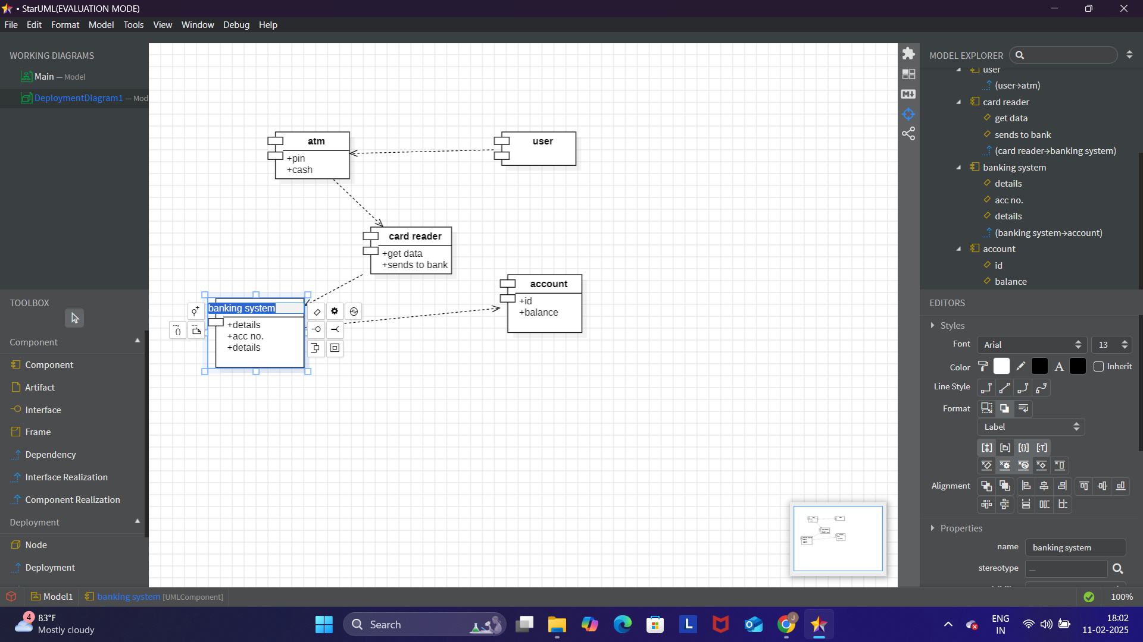

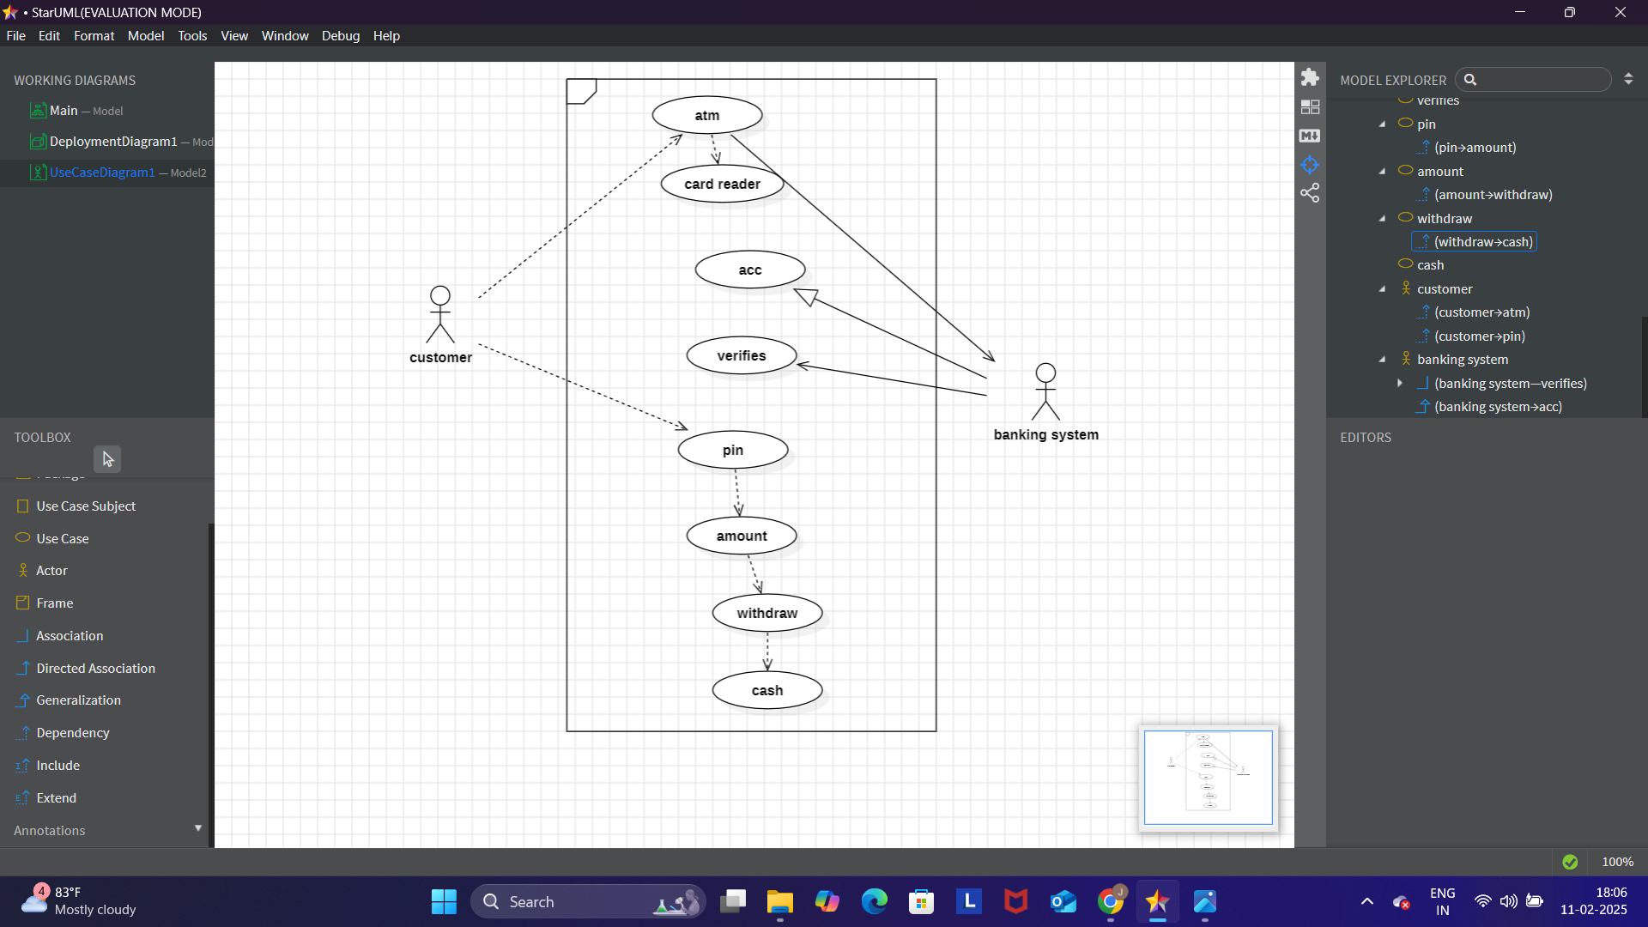

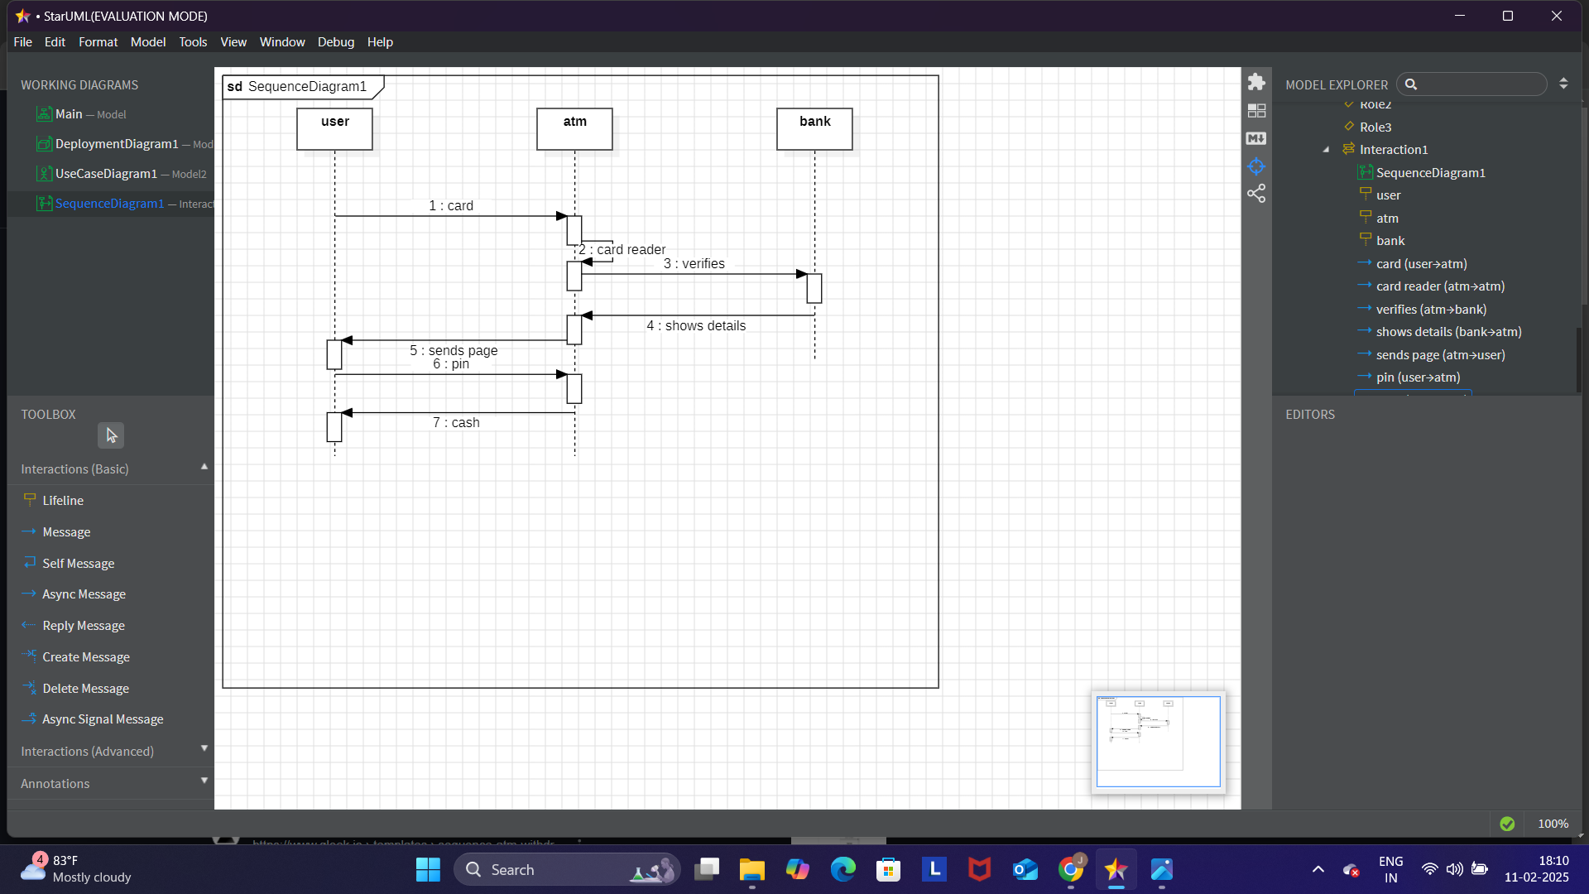

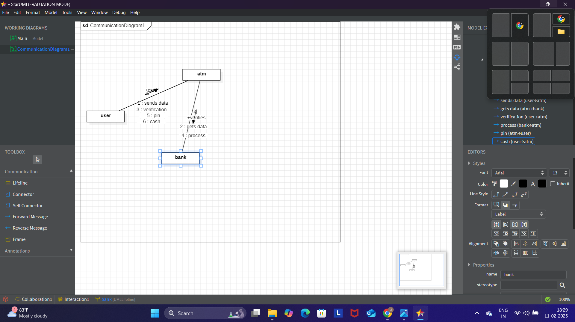
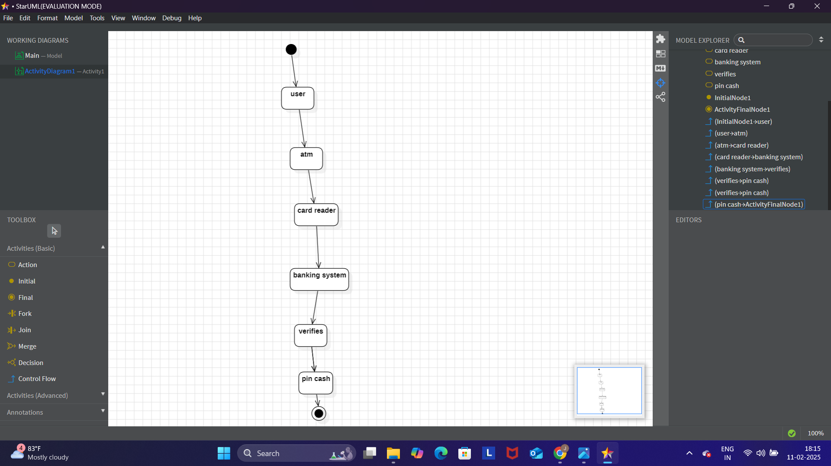

RESULT:

The resulting UML diagram effectively illustrates the ATM System's functionalities and workflows, ensuring better understanding and system design.

